TMT/Belgaum/S0762/2026 23-04-2026

To,
Salma kagzi
Company : Rk enterprises
Mobile No :+919019773027
Email : rkenterprisesbelgaum@gmail.com
City : Belgaum , State :Karnataka

Dear Sir,
SUB :- SUPPLY OF Aluminum Bailing press

With reference to our discussions regarding your requirement of steel and Aluminum Bailing Press. We are glad to inform you that, we are in a position to supply you the required equipment. The following are the specifications and our terms and conditions.

Specifications of the equipment

Bailing chamber : 300(H) x 250(W) x 670 (L) mm

Bale Size : 150(H) x 125(W) x 100-150 (L)

Weight of bale (approx.) : 10-15 kg

Body : MS Fabricated@ stress relieved

Pump : High pressure vane pump

Oil : 68 grades

Main Ram Tonnage : 35 Ton

Working pressure : 225 bar

Motor power : 10 Hp

Oil Tank : 200 lts

S No | Description of the unit | Offer/unit
1. | Aluminum bailer press with 10 hp drive with 2 cylinder is with the following specifications. | Rs 4,60,000/- (Four Lakhs Sixty Thousand only)

GENERAL TERMS & CONDITIONS:

- Price quoted per unit ex-work. Hyderabad.
- Following charges are additional to your account.
- Freight Charge : As actual to be borne by you.
- Excise : Extra As Applicable
- Sales Tax : Extra as applicable
- Packing charge : As actual to be borne by you.
- Insurance : As actual to be borne by you.
- Payment : 50% advance along with order balance before delivery but after inspection at our works.
- Delivery : within 2 months
- Validity : One month from the date of submission.
- Inspection : Inspection at our works prior to dispatch.
- Warranty : The machine is warranted for a period of 12 months from the date of dispatch against any manufacturing defects/ faulty material or bad workmanship of any part or component but not against any kind of abnormal or improper use of machine. Defective part or component will be replaced or repaired free of cost. Electrical components are outside the scope of this warranty.
- Commissioning : Erection & commissioning done by you, but required technical support & guidance provide by us at additional cost.

NOTE:
- Oil is not in scope of our supply.
- Raw material for trial is to be arranged by you at your cost.

We are sure you will find our offer in line with your requirements. Should you require any further clarification please contact 9246221106

Thanking you and assuring you of our best services

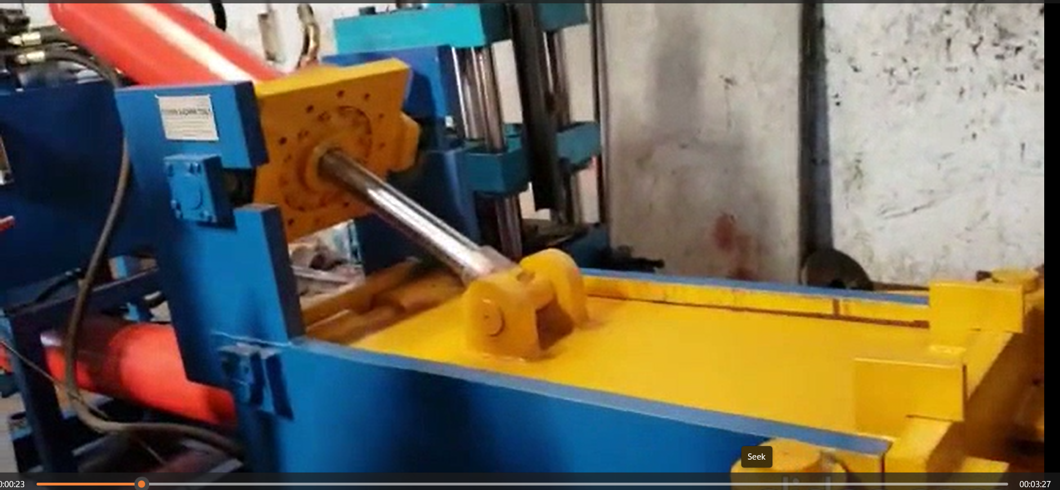

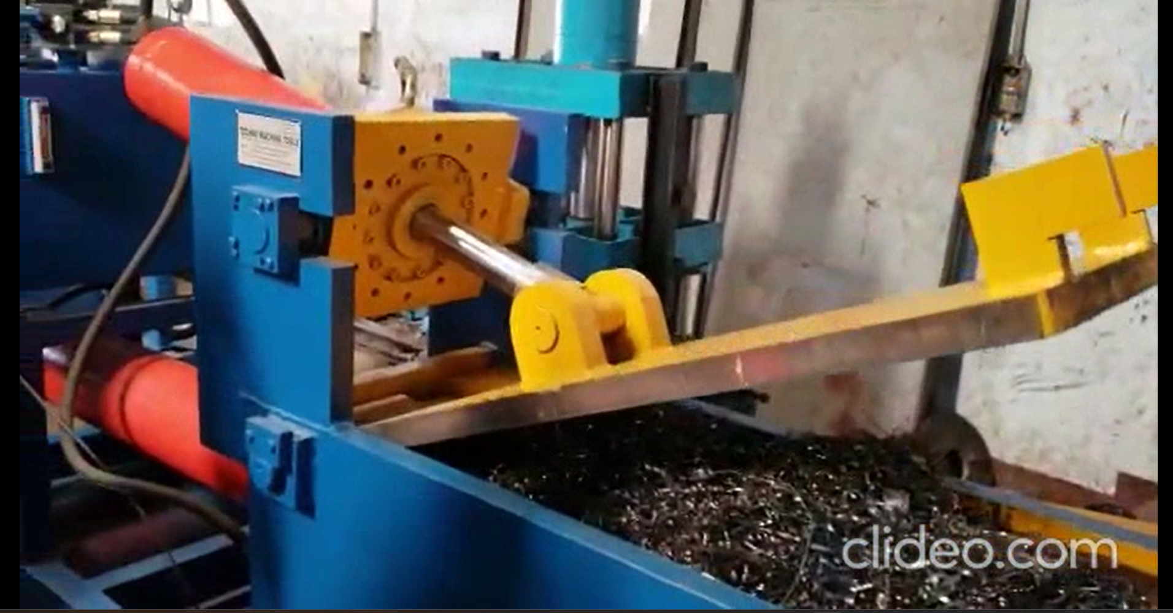

For TECHNO MACHINE TOOLS

(T. SIVARAMAKRISHNA)

Our bank details

Techno Machine Tools
IFSC CODE: PUNB0115310
ACC. NO: 11534015002032

